

Finished Basement Details
Based on the 2021 International Residential Code
(Designed and Printed January 2026)

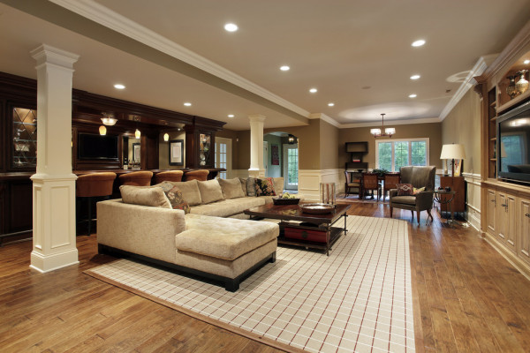

CONTENTS

General Information...……………………………. | 2 | Energy Requirements…………………...……….. | 6
Scope..…………………………………………….. | 2 | Emergency Escape/Rescue Openings.………... | 6
Room Sizes/Ceiling Heights/Fixture Clearances Framing Requirements…………………………… | 2  2 | Mechanical Requirements………….…………....  Drywall Requirements……………….………….... | 6  7
Electrical Requirements…………………………..  Plumbing Requirements………………………….. | 3  5 | Elevation View Example………...………………..  Application Checklist……………………………… | 8  9

THE INFORMATION CONTAINED IN THIS DOCUMENT REPRESENTS ONLY A PORTION OF CODE-RELATED REQUIREMENTS AND IS NOT A COMPLETE OR EXHAUSTIVE LIST – REFER TO THE ACTUAL CODE PRINTING. ALL RESIDENTIAL CONSTRUCTION MUST BE IN CONFORMANCE WITH THE 2021 INTERNATIONAL RESIDENTIAL CODE (IRC) AND TOWNSHIP ORDINANCES, WHICH SUPERCEDES ANY DISPREPANCY LOCATED HEREIN. APPLICABLE 2021 IRC CITATIONS REFERENCED IN BRACKETS.

General Information

- A building permit is required to finish a basement (or portion thereof). Work shall not commence until the permit has been approved and issued.
- The following inspections are mandatory:
  - Framing
  - Rough/In-ground Plumbing (as applicable)
  - Rough Sprinklers/Fire-Suppression System (as applicable)
  - Shower Liner Test (as applicable)
  - Rough Electrical
  - Rough Mechanical (as applicable)
  - Insulation
  - Drywall
  - Final (Building/Plumbing/Electrical/Mechanical)
- It shall be the duty of the permit holder or their agent to notify the building official that such work is ready for inspection. It shall be the duty of the person requesting any inspections required by this code to provide access and means for inspection of such work.
- All inspections must be made at least 48 hours in advance. All construction documents shall be on the jobsite and provided to inspector upon request. You may schedule an appointment for inspection by calling the Keycodes Inspection Agency at (610) 866-9663 option 2 or emailing insp@keycodes.net Monday thru Friday 8:00a.m. – 4:30p.m.
- The finished basement may not be occupied until a certificate of occupancy is issued.

Scope

The provisions of the 2021 International Residential Code shall apply to the construction, alteration, movement, enlargement, replacement, repair and use & occupancy of one- and two-family dwellings.

Minimum Room Sizes / Ceiling Heights / Fixture Clearances

- Habitable Rooms (including bedrooms): 70 square-feet with a minimum 7-foot dimension – except kitchens. [R304]
- Ceiling Height (habitable space, hallways and finished basements): 7-feet. [R305.1]
- Basements: Beams, girders, ducts or other obstructions shall be permitted to project within 6’-4” of finished floor. [R305.1]
- Bathrooms, Toilet Rooms and Laundry Rooms: 6’-8”. [R305.1]
- Water Closet: minimum 21-inch clearance in front of bowl, 15-inches from centerline of bowl to wall or other obstruction. [R307.1/R2705.1]
- Vanities: minimum 21-inch clearance in front of fixture. [R307.1]
- Showers: minimum 900 square inches, minimum 30-inches least dimension, 24-inch clearance in front of opening. [R307.1]
- Hallways: 36-inches minimum finished width. [R311.6]
- Stairways: The headroom shall be not less than 6’-8” when measured vertically from the sloped line adjoining the tread nosing. [R311.7.2] The clear width at all points above the permitted handrail height and below the required headroom height shall be minimum 36-inches. [R311.7.1]

Framing Requirements

Studs, Plates and Joists:
- Wood sill plates, installed in direct contact with concrete slab, shall be pressure-preservative-treated unless separated from such slab by an impervious moisture barrier. [R317.1]
- Studs in non-bearing walls shall be spaced not more than 24-inches on center. [R602.3.1]
- Bearing wall studs shall not be notched to a depth more than 25% of its width. Studs drilled over 40% up to 60% shall be doubled or provided with an approved stud shoe installed in accordance with the manufacturer’s installation instructions. [R602.6]
- Non-bearing wall studs may be notched up to 40% and drilled up to 60% of its width. [R602.6]
- Conventional floor joists may be notched per Section R502.8. Diameters of drill holes shall not exceed one-third the depth of the member and shall not be closer than 2-inches from the top or bottom of the joist. [R502.8.1]
- Trusses, structural composite lumber, structural glued-laminated members, cross-laminated timber members and I-joists may not be altered, drilled or notched unless approved by the manufacturer or registered design professional. [R502.8.2]
- Any hole or notch located less than 1-1/4-inches from the face of a stud, sole plate or top plate, for which piping is installed (other than cast-iron or galvanized steel) shall have a 16-guage shield plate. The shield plate shall extend not less than 2-inches above sole plates and below top plates. [P2603.2.1]

Stairways:
- The headroom in stairways shall be not less than 6’-8” when measured vertically from the sloped line adjoining the tread nosing. [R311.7.2]
- A landing shall be provided at the bottom of the stairs and shall be minimum 36-inches in the direction of travel by not less than the width of the stairs served. [R311.7.6]
- A handrail shall be installed on at least one side of stairs with more than 3 risers. The top of the handrail shall be 34-38 inches, measured from the tread nosing. [R311.7.8.1] The ends of the handrail shall terminate into a newel post, wall or safety terminals. [R311.7.8.4] Grip-size shall be Type I or Type II per Section R311.7.8.5.
- Handrails may project a maximum of 3-1/2-inches into the required width of the stairs. [PA UCC]
- Minimum tread depth shall be 9-inches between nosings. Maximum riser height shall be 8-1/4-inches. Maximum variation shall not exceed 3/8-inch along the stairway. [PA UCC]
- Guards shall be installed on open-sided stairs located more than 30-inches above the floor below. [R312.2.1] Guard height shall be a minimum 34-inches when measured from the stair nosing. [R312.1.2] Guard openings may not allow the passage of a 4-3/8-inch sphere except that the triangular opening formed by the riser, tread and bottom rail shall not allow the passage of a 6-inch sphere. [R312.1.3]

Draftstopping:
- Where the ceiling is suspended under the floor framing or the floor framing is constructed of truss-type open-web or perforated members, draftstops shall be installed so that the area of the concealed space does not exceed 1,000 square feet. [R302.12]
- Draftstopping materials are limited to ½-inch gypsum board, 3/8-inch wood structural panels or other materials approved by the construction code official. [R302.12.1]

Fireblocking:
- Fireblocking shall be installed in the following locations [R302.11]:
  - In concealed spaces of stud walls and partitions vertically at the ceiling and floor levels.
  - At interconnections between concealed vertical and horizontal spaces such as occur at drop ceilings, cove ceilings and soffits.
  - At openings around vents, pipes, cables, ducts and wires at ceiling and floor levels.
    - Fireblocking materials shall be 2-inch nominal lumber, 23/32-inch wood structural panels with joints backed by 23/32-inch wood structural panels, ¾-inch particleboard with joints backed by ¾-inch particleboard, ½-inch gypsum board, ¼-inch cement-based millboard or batts or blankets of mineral wool or glass fiber which is retained in place. [R302.11.1]

Electrical Requirements

Electrical installations and/or alterations shall comply with the 2021 International Residential Code (and any PA UCC amendments as applicable) or NFPA 70. [E3401.1] Conduit bodies and junction, pull and outlet boxes shall be accessible without removing any part of the building. [E3905.10]

Electrical Panel Clearances and Location:
- The indoor working space for electrical panels shall be minimum 36-inches in depth, minimum 30-inches in width (or not less than the width of such equipment) and minimum 6’-6” in height above the floor. Where existing panelboards are not rated in excess of 200-amps, the height limitation may be less than 6’-6”. [E3405.2 exception 1]
- Equipment, piping and ducts not associated with the electrical equipment shall not be installed between the floor and to a height of 6-feet above the panel board, or to the structural ceiling, whichever is lower. [E3405.3]
- Panel boards and overcurrent protection devices shall not be located in clothes closets, bathrooms or over the steps of a stairway. [E3405.5]
- All circuits in the electrical panel shall be legibly identifiable. [E3706.2]

Receptacle Outlets:
Receptacles shall be installed in every kitchen, family room, dining room, living room, parlor, library, den, sunroom, bedroom, recreation room or similar room or area of a dwelling. [E3901.2]
- Receptacles shall be installed so that no point along the floor line of any wall space is more than 6-feet from any receptacle outlet. [E3901.2.1] – Refer to illustration below.

- Bathrooms shall be provided with at least one GFCI Protected wall receptacle on a dedicated 20-amp circuit located within 36-inches of the outside edge of each lavatory basin. [E3901.6; E3703.4]
- Hallways of 10-feet or more than shall have at least one receptacle outlet. [E3901.10]
- Countertop receptacles shall comply with Section E3901.4.
- Arc-fault circuit-interrupter protection shall be provided where required by E3902.
- All receptacles shall be tamper-resistant. [E4002.14]

Smoke Detectors:
Smoke detectors shall be comply with NFPA 72 and listed in accordance with UL 217 [R314.1.1] and installed in the following locations: [R314.3]
- In each sleeping room.
- Outside each separate sleeping area in the immediate vicinity of the bedroom(s).
- On each story of the dwelling.
- Not less than 3-feet from the door or opening of a bathroom that contains a bathtub or shower.
- In the hallway and in the room open to the hallway in dwelling units where the ceiling height of a room open to a hallway serving bedrooms exceeds that of the hallway by 24 inches or more.

Carbon Monoxide Detectors:
Carbon monoxide alarms shall be listed in accordance with UL 2034 [R315.1.1] and installed in the following locations IF the dwelling contains a fuel-fired appliance or has an attached garage with an opening that communicates with the dwelling unit: [R315.3]
- Outside each separate sleeping area in the immediate vicinity of the bedroom(s).
- Where a fuel-burning appliance is located in a bedroom or its attached bathroom, the carbon monoxide detector shall be installed within the bedroom.

Lighting Requirements:
- Glazing area of at least 8-percent of the floor area shall be provided for habitable rooms unless an artificial light source is installed. [R303.1]
- Interior stairway illumination shall consist of an artificial light source, capable of illuminating treads and landings to not less than 1-foot candle, and a wall switch installed at each floor level where that stairway has six or more risers. [R303.7]
- Exterior stairway illumination shall consist of an artificial light source at the top landing of the stairway. Where stairway serves basement from the outdoor grade level, the light source shall be located at the bottom landing. [R303.8]

Ventilation Requirements:
- Minimum openable area to the outdoors shall be not less than 4-percent of the floor area for habitable rooms unless a whole-house mechanical ventilation system is provided. [R303.1]
- Bathrooms shall be provided with a minimum of 1.5-square feet of opening glazing unless a local exhaust system of 50 cfm (intermittent) or 20 cfm (continuous) is provided. [R303.3]

Plumbing Requirements

- All fixtures, water lines and drain/waste/vent lines shall be installed in accordance with the 2021 International Residential Code.
- Fixtures shall be spaced per the following Figure. [R307.1]

- Shower liner test is required to be witnessed by an inspector for all field-fabricated liners. The shower floor and receptor shall be filled with not less than 2-inches of water and maintained free of leaks for 15-minutes. [P2503.6]

Energy Requirements

Insulation shall comply with one of the following methods:
- 2021 IRC – Prescriptive [N1102.1]:
  - Below-grade walls: R-15 (continuous) or R-19 (cavity). May use R-13 (cavity) with R-5 continuous.
  - Above-grade walls: R-20 (cavity) or R-13 (cavity) with R-5 continuous.
- Submittal of an approved REScheck or other national, state or local energy program.

Emergency Escape/Rescue Openings

Basements and every sleeping room shall have not less than one operable emergency escape and rescue opening which shall open directly into a public way or to a yard or court that opens into a public way. [R310.1/Ord. §55-27]

Grade Floor Openings:
- Minimum 5-square feet of net clear opening. [R310.2.1]
- Net clear opening height: 24-inches. [R310.2.2]
- Net clearing opening width: 20-inches. [R310.2.2]
- Height above floor: 44-inches maximum from finished floor to clear opening. [R310.2.3]
- Emergency escape and rescue openings under decks are permitted if such can be fully opened and is provided with a path not less than 36-inches in height to a yard or court. [R310.2.4]

Window Wells:
Where a window is provided as an emergency escape and rescue opening and, where the sill height is below grade, it shall be provided with a window well. [R310.4]
- Horizontal window well area shall not be less than 9-square feet and a horizontal project and width of minimum 36-inches. [R310.4.1] Exception – A ladder or steps are allowed to encroach not more than 6-inches into the required dimensions.
- Window wells with a depth greater than 44-inches shall be equipped with a permanent ladder or steps, usable with the window in a fully opened position. Ladders of rungs shall have a minimum inside width of 12-inches, shall project not less than 3-inches from the wall and be spaced not more than 18-inches on center vertically. Steps shall have an inside minimum width of 12-inches, a minimum tread depth of 5-inches and a maximum riser height of 18-inches. [R310.4.2]
- Window wells shall have a proper drainage method installed. [R310.4.3]

Mechanical

Appliances:
- Mechanical appliances shall be accessible for service, inspection, repair and replacement without removing permanent construction, other appliances, or any other piping or ducts not associated to such appliance. [M1305.1]
- Clearance shall be minimum 30-inches at the front or service side of the appliance. [M1305.1.1]
- Adequate combustion air shall be provided for each appliance according to the manufacturer’s installation instructions. [G2407.1]
- Gas appliances shall not be installed in sleeping rooms, bathrooms, toilet rooms, storage closets or in any room that opens only into such rooms or spaces unless it meets one of the conditions of Section G2406.2.
- Fuel-fired water heaters shall not be located in a storage closet. When such water heater is installed in a bedroom or bathroom, it shall be in a sealed enclosure designed so that combustion air will not be taken from the living space. [M2005.2]
- Where one or more gas, liquid or solid fuel-burning appliance that is neither direct-vent nor uses a mechanical draft venting system is located within a dwelling, kitchen exhaust hoods capable of exhausting more than 400 cfm shall be provided with makeup air equal to the exhaust air rate. [M1503.6]
Heating Requirements:
Habitable rooms shall be provided with heating facilities capable of maintaining a room temperature of at least 68°F. The use of portable space heaters to meet this requirement is prohibited. [R303.10]

Drywall

- Enclosed, accessible space under stairs shall have walls, under-stair surface and any soffits protected on the enclosed side with ½-inch gypsum board. [R302.7]
- Access panels shall be provided for all mechanical dampers, meters, backflow devices, plumbing valves and manifolds, sanitary cleanouts and gas valves and manifolds. [M1401.2/G2420.1.3/P2903.9.3]
- Screws (Type W or S) shall penetrate wood framing members not less than 5/8-inch. Screws attaching gypsum to cold-formed steel shall be minimum No. 6 screws and penetrate framing members not less than 3/8-inch. [R702.3.5.1] Spacing of screws, nails and nails lengths shall comply with Table R702.3.5.
- Water-resistant gypsum board shall not be installed over Class I or II vapor retarders in shower or tub compartments. [R702.3.7]

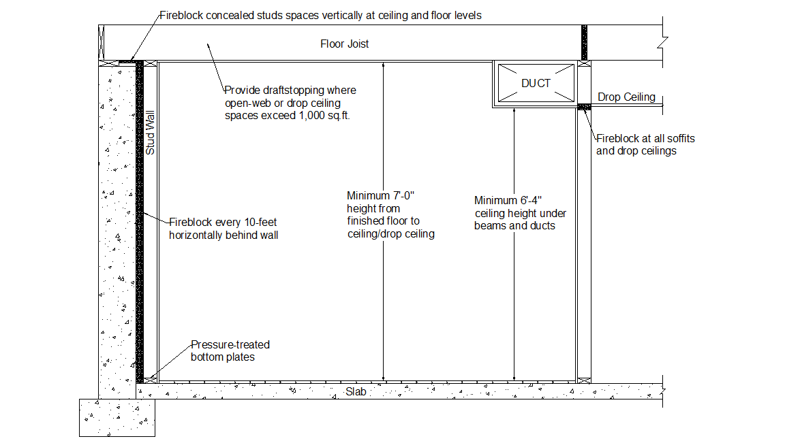
ELEVATION VIEW DETAILS
FINISHED BASEMENT APPLICATION CHECKLIST

Municipality: Date:

Site Address:

Applicant Name: Phone: ______
Contractor Name: Phone: ______

Total Square Feet of Proposed Finished Basement:____________

Floor Plan: Provide 2 Sets of Plans Floor Plan - Indicate Use of Room(s)

Construction Details Provided Ceiling Height:_________

Pressure-Treated Sole Plates Type of Ceiling: Drywall / Drop Ceiling / Other

Smoke Detector(s) Noted Indicate/Describe any Structural Alterations

Window/Door Locations Shown Emergency Escape/Rescue Opening(s)
Identified

Plumbing: Will Plumbing Work Take Place? If bathroom proposed, submit layout
plan/clearances
Mechanical: Will Mechanical Work Take Place?

Proposed Heating Method for Space:_________________

Energy: Proposed Insulation R-Value (Walls):_________________

*Note: A carbon monoxide alarm is required to be installed outside of each separate sleeping area in the immediate vicinity of the bedroom(s) IF the dwelling contains a fuel-fired appliance or has an attached garage with an opening that communicates with the dwelling unit.

