
Typical Deck Details
Based on the 2021 International Residential Code
and Pennsylvania Uniform Construction Code Amendments
(Designed and Printed January 2026)

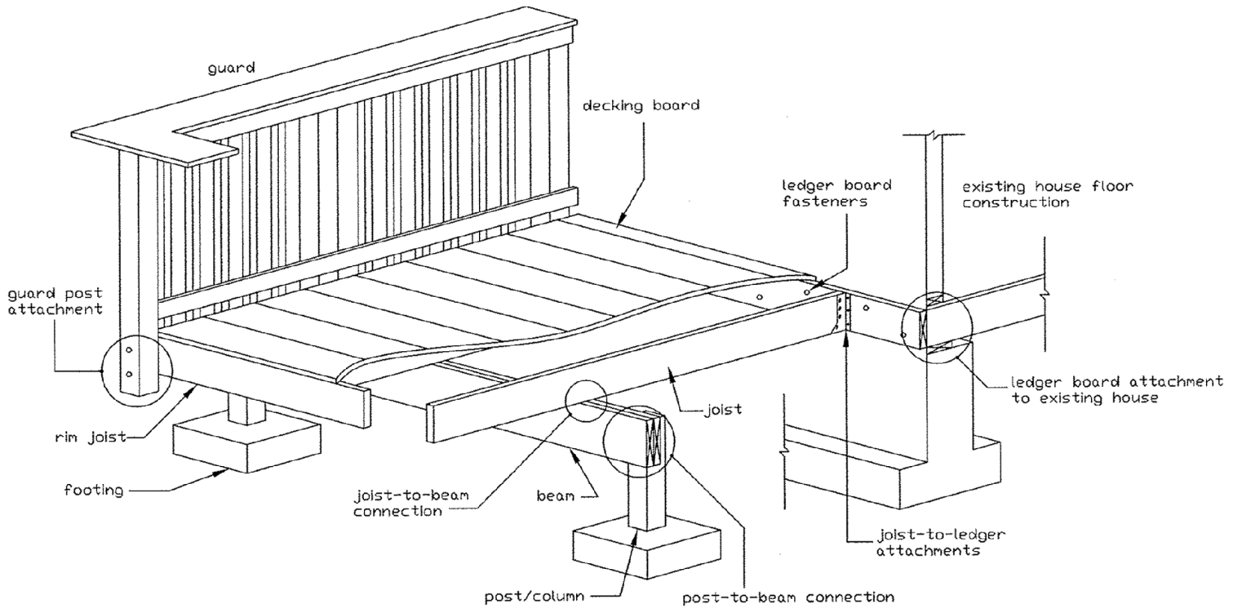

CONTENTS

General Information...………………………… | 2 | Lateral Load Connection………………………... | 9
Footings …………………………………….... | 3 | Framing at Cantilevered Floor System…………... | 10
Joist Sizing and Span………………………….. | 4 | Lateral Restraints at Supports…..……………….. | 11
Beam Sizing and Spans………………..………. | 5 | Guard Requirements………...................................... | 11
Deck Post Allowable Heights…………………. | 7 | Guard Post Installation………….………………. | 12
Deck Post-to-Beam Connections……………… | 7 | Stair Handrail Requirements....…………………... | 12
Deck Post-to-Footing Connections……………. | 8 | Stairway Requirements…………………………... | 12
Bracing………..……………………………….. | 8 | Glazing in Hazardous Locations………………… | 13
Ledger Attachment…………………………...... | 8 | Decking Requirements…………………………... | 13
Ledger Board Fastener Spacing………………… | 9 | Application and Process for Permit…..………….. | 14
THE USE OF THIS PACKAGE APPLIES ONLY TO SINGLE LEVEL, RESIDENTIAL DECKS SUPPORTING A TOTAL LOAD OF 50 LBS/SQFT. CONCENTRATED LOADS, SUCH AS HOT TUBS, POOLS, OUTDOOR KITCHENS, ETC. MUST BE EVALUATED/APPROVED BY A REGISTERED DESIGN PROFESSIONAL. DECKS MUST BE CONSTRUCTED IN CONFORMANCE WITH THE 2021 INTERNATIONAL RESIDENTIAL CODE AND THE PENNSYLVANIA UNIFORM CONSTRUCTION CODE, WHICH SUPERCEDES ANY DISPREPANCY LOCATED HEREIN. *CODE REFERENCES ARE [BRACKETED]*
GENERAL INFORMATION

- Definition: Deck – An exterior floor system supported on at least two opposing sides by an adjoining structure and/or posts, piers, or other independent supports.
- All wood in contact with the ground, embedded in concrete in direct contact with the ground or embedded in concrete exposed to the weather that supports permanent structures intended for human occupancy shall be approved pressure-preservative treated wood suitable for ground contact use. [R317.1.2] Wood materials shall be No. 2 grade or better. [R507.2.1] Cuts, notches and drilled holes shall be treated in accordance with R317.1.1. [R507.2.1]
- Wood/plastic composites used in deck boards, stair treads, handrails and guardrail systems shall comply with the provisions of ASTM D 7032 and shall be installed per the manufacturer’s instructions. [R507.2.2]
- Metal fasteners and connectors shall be of hot-dipped, zinc-coated galvanized steel, stainless steel, silicon bronze or copper and be in accordance with Section R317.3 and Table R507.2.3. [R507.2.3]
- Where exterior decks attach to a wall or floor assembly of wood-frame construction, corrosion-resistant metal flashing or approved non-metallic material shall be installed to prevent water from contacting the house band joist. [R703.4/R507.2.4]
*Bare aluminum shall not be used in direct contact with lumber treated with preservatives that contain copper (such as ACQ, Copper Azole or ACZA)*
- All of the following inspections are required during construction of deck:
  - Footing inspections are required before the concrete is poured. All holes must be cleaned and free from loose dirt. Helical piers require an as-built report sealed by a PA-registered design professional.
  - Framing inspections must be completed before the decking may be attached, unless otherwise noted.
  - Final inspection shall be scheduled when all construction of the deck has been completed.
  - NOTE: ALL INSPECTIONS ARE MANDATORY BY LAW. FAILURE TO OBTAIN THE INSPECTIONS MAY CAUSE VIOLATIONS AND FINES.
- It shall be the duty of the permit holder or their agent to notify the building official that such work is ready for inspection. It shall be the duty of the person requesting any inspections required by this code to provide access and means for inspection of such work.
- All inspections must be made at least 48 hours in advance. All construction documents shall be on the jobsite and provided to inspector upon request. You may schedule an appointment for inspection by calling Keycodes Inspection Agency at (610) 866-9663 option 2 or email insp@keycodes.net Monday - Friday 8:00a.m. – 4:30p.m.
- Decks may not be occupied until all inspections have been completed and a final approval (in the form of a certificate of occupancy) has been issued by the Building Code Official.

FOOTINGS

All footers must be a minimum of 36” below grade and bear on undisturbed, natural soil. [R507.3.3] Free-standing decks not more than 600 sq.ft. with a height of 10-feet or less, shall have footings placed a minimum of 12-inches below the undisturbed natural soil. [R403.1.4.1 exception 1/R507.3.2] Deck footings closer than 5’-0” to an existing exterior house wall must bear at the same elevation as the existing footer of the house. The size of footings supporting piers and columns shall be based on tributary load and the allowable soil pressure of 1500 psf (unless soil test data is provided). [R507.3.1] Do not construct footings over utility lines or enclosed meters - Call 811 before you dig.

To determine pier minimum width, first calculate tributary area supported by each column/post (see Figure 1).
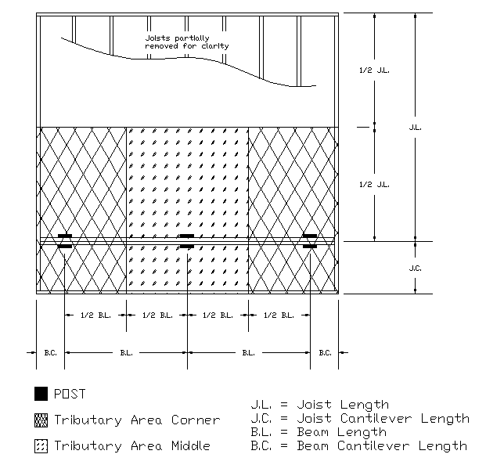
Figure 1

Then, use the tributary area to find required footing size in Table 1 (on following page):

TABLE 1
Live Load (psf) | Tributary Area (sq.ft.) | Load-bearing Value of Soils = 1,500 psf
Live Load (psf) | Tributary Area (sq.ft.) | Side of square footing (inches) | Diameter of round footing (inches) | Thickness (inches)
40 | 5 | 7 | 8 | 6
40 | 20 | 10 | 12 | 6
40 | 40 | 14 | 16 | 6
40 | 60 | 17 | 19 | 6
40 | 80 | 20 | 22 | 7
40 | 100 | 22 | 25 | 8
40 | 120 | 24 | 27 | 9
40 | 140 | 26 | 29 | 10
40 | 160 | 28 | 31 | 11
- Interpolation permitted. Extrapolation not permitted.
- Footing dimension shall allow complete bearing of the post.
- If the support is a brick or CMU pier, the footing shall have a minimum 2-inch projection on all sides.

JOIST SIZING AND SPAN

Maximum allowable spans for wood deck joists shall be in accordance with Table 2 and the Figure 2 below. Deck joists are permitted to cantilever not greater than one-fourth of the actual, adjacent span or the maximum cantilever length specified in Table 2. [R507.6] Joist framing into the side of a ledger board or beam shall be supported by approved joist hangers. [R507.6.1]

TABLE 2
MAXIMUM DECK JOIST SPANS
Species ^{b} | Size | Allowable Joist Span ^{b,c} |  |  | Maximum Cantilever ^{d,f}
Species ^{b} | Size | Joist Spacing (inches) |  |  | Joist back span (inches) ^{g}
Species ^{b} |  | 12 | 16 | 24 | 4 | 6 | 8 | 10 | 12 | 14 | 16 | 18
Southern pine | 2 x 6 | 9-11 | 9-0 | 7-7 | 1-0 | 1-6 | 1-5 | NP | NP | NP | NP | NP
Southern pine | 2 x 8 | 13-1 | 11-10 | 9-8 | 1-0 | 1-6 | 2-0 | 2-6 | 2-3 | NP | NP | NP
Southern pine | 2 x 10 | 16-2 | 14-0 | 11-5 | 1-0 | 1-6 | 2-0 | 2-6 | 3-0 | 3-4 | 3-4 | NP
Southern pine | 2 x 12 | 18-0 | 16-6 | 13-6 | 1-0 | 1-6 | 2-0 | 2-6 | 3-0 | 3-6 | 4-0 | 4-1
Douglas-fir-larch^{e}, Hem-fir^{e},  Spruce-pine-fir^{e} | 2 x 6 | 9-6 | 8-4 | 6-10 | 1-0 | 1-6 | 1-4 | NP | NP | NP | NP | NP
Douglas-fir-larch^{e}, Hem-fir^{e},  Spruce-pine-fir^{e} | 2 x 8 | 12-6 | 11-1 | 9-1 | 1-0 | 1-6 | 2-0 | 2-3 | 2-0 | NP | NP | NP
Douglas-fir-larch^{e}, Hem-fir^{e},  Spruce-pine-fir^{e} | 2 x 10 | 15-8 | 13-7 | 11-1 | 1-0 | 1-6 | 2-0 | 2-6 | 3-0 | 3-3 | NP | NP
Douglas-fir-larch^{e}, Hem-fir^{e},  Spruce-pine-fir^{e} | 2 x 12 | 18-0 | 15-9 | 12-10 | 1-0 | 1-6 | 2-0 | 2-6 | 3-0 | 3-6 | 3-11 | 3-11
Redwood^{f},  Western cedars^{f},  Ponderosa pine  Red pine ^{f} | 2 x 6 | 8-10 | 8-0 | 6-10 | 1-0 | 1-4 | 1-1 | NP | NP | NP | NP | NP
 | 2 x 8 | 11-8 | 10-7 | 8-8 | 1-0 | 1-6 | 2-0 | 1-11 | NP | NP | NP | NP
 | 2 x 10 | 14-11 | 13-0 | 10-7 | 1-0 | 1-6 | 2-0 | 2-6 | 3-0 | 2-9 | NP | NP
 | 2 x 12 | 17-5 | 15-1 | 12-4 | 1-0 | 1-6 | 2-0 | 2-6 | 3-0 | 3-6 | 3-8 | NP
a. Dead load = 10 psf. Snow load not assumed to be concurrent with live load.
b. No. 2 grade, wet service factor included.
c. L/∆ = 360 at main span.
d. L/∆ = 180 at cantilever with a 220-pound point load applied to end.
e. Includes incising factor.
f. Incising factor not included.
g. Interpolation allowed. Extrapolation is not allowed.
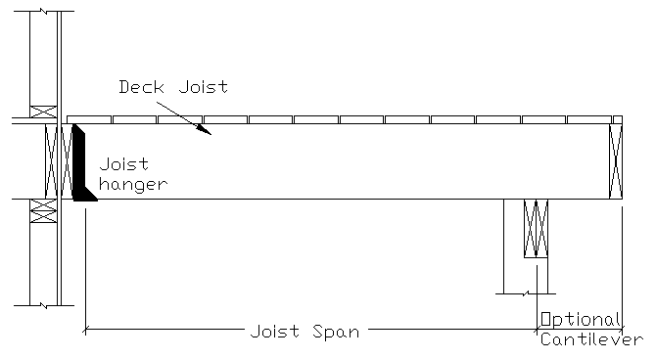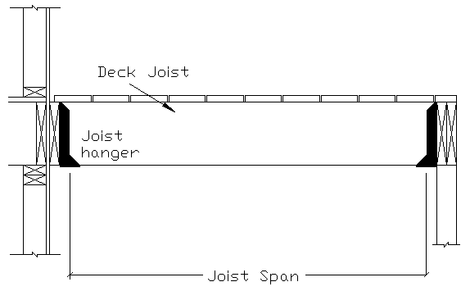
Figure 2

BEAM SIZE AND ASSEMBLY REQUIREMENTS

Maximum allowable spans for wood deck beams shall be in accordance with Table 4 (following page) using the effective deck joist span. The effective deck joist span is calculated by dividing the actual joist cantilever length by the actual joist span length and using Table 3 below. Beam spans are measured to the centerline of each post. Beam plies shall be fastened with two rows of 10d nails minimum at 16 inches on center along each edge. Beams shall be permitted to cantilever at each end up to one-fourth of the actual beam span. Splices of multi-span beams shall be located at interior post locations. [R507.5] The ends of each beam shall have not less than 1.5 inches of bearing on wood or metal and not less than 3 inches on concrete or masonry. [R507.5.1] Beams may not be supported by deck ledgers or band joists. [R507.9.1.1] If using engineered lumber, an engineer’s seal is required upon submission. [R301.1.3]

TABLE 3
JOSIT SPAN FACTORS FOR CALCULATING EFFECTIVE DECK JOIST SPAN
(for use with Table 4)
C/Jª | JOIST SPAN FACTOR
0 (no cantilever) | 0.66
1/12 (0.87) | .72
1/10 (0.10) | .80
1/8 (0.125) | .84
1/6 (0.167) | .90
1/4 (0.250) | 1.00
- C = actual joist cantilever length (feet); J = actual joist span length (feet).

TABLE 4
MAXIMUM DECK BEAM SPAN—40 PSF LIVE LOAD
SPECIES | SIZE | EFFECTIVE DECK JOIST SPAN LENGTH (feet)
SPECIES | SIZE | 6 | 8 | 10 | 12 | 14 | 16 | 18
SPECIES | SIZE | MAXIMUM DECK BEAM SPAN LENGTH (feet-inches)
Southern Pine | 1 - 2 x 6 | 4-7 | 4-0 | 3-7 | 3-3 | 3-0 | 2-10 | 2-8
Southern Pine | 1 - 2 x 8 | 5-11 | 5-1 | 4-7 | 4-2 | 3-10 | 3-7 | 3-5
Southern Pine | 1 - 2 x 10 | 7-0 | 6-0 | 5-5 | 4-11 | 4-7 | 4-3 | 4-0
Southern Pine | 1 - 2 x 12 | 8-3 | 7-1 | 6-4 | 5-10 | 5-5 | 5-0 | 4-9
Southern Pine | 2 - 2 x 6 | 6-11 | 5-11 | 5-4 | 4-10 | 4-6 | 4-3 | 4-0
Southern Pine | 2 - 2 x 8 | 8-9 | 7-7 | 6-9 | 6-2 | 5-9 | 5-4 | 5-0
Southern Pine | 2 - 2 x 10 | 10-4 | 9-0 | 8-0 | 7-4 | 6-9 | 6-4 | 6-0
Southern Pine | 2 - 2 x 12 | 12-2 | 10-7 | 9-5 | 8-7 | 8-0 | 7-5 | 7-0
Southern Pine | 3 - 2 x 6 | 8-6 | 7-5 | 6-8 | 6-1 | 5-8 | 5-3 | 4-11
Southern Pine | 3 - 2 x 8 | 10-11 | 9-6 | 8-6 | 7-9 | 7-2 | 6-8 | 6-4
Southern Pine | 3 - 2 x 10 | 13-0 | 11-2 | 10-0 | 9-2 | 8-6 | 7-11 | 7-6
Southern Pine | 3 - 2 x 12 | 15-3 | 13-3 | 11-10 | 10-9 | 10-0 | 9-4 | 8-10
Douglas fir-larch  Hem-fir  Spruce-pine-fir | 1 - 2 x 6 | 4-1 | 3-6 | 3-0 | 2-8 | 2-5 | 2-3 | 2-1
Douglas fir-larch  Hem-fir  Spruce-pine-fir | 1 - 2 x 8 | 5-6 | 4-8 | 4-0 | 3-6 | 3-2 | 2-11 | 2-9
Douglas fir-larch  Hem-fir  Spruce-pine-fir | 1 - 2 x 10 | 6-8 | 5-10 | 5-1 | 4-6 | 4-1 | 3-9 | 3-6
Douglas fir-larch  Hem-fir  Spruce-pine-fir | 1 - 2 x 12 | 7-9 | 6-9 | 6-0 | 5-6 | 5-0 | 3-9 | 3-6
Douglas fir-larch  Hem-fir  Spruce-pine-fir | 2 - 2 x 6 | 6-1 | 5-3 | 4-9 | 4-4 | 3-11 | 3-7 | 3-3
Douglas fir-larch  Hem-fir  Spruce-pine-fir | 2 - 2 x 8 | 8-2 | 7-1 | 6-4 | 5-9 | 5-2 | 4-8 | 4-4
Douglas fir-larch  Hem-fir  Spruce-pine-fir | 2 - 2 x 10 | 10-0 | 8-7 | 7-9 | 7-0 | 6-6 | 6-0 | 5-6
Douglas fir-larch  Hem-fir  Spruce-pine-fir | 2 - 2 x 12 | 11-7 | 10-0 | 8-11 | 8-2 | 7-7 | 7-1 | 6-8
Douglas fir-larch  Hem-fir  Spruce-pine-fir | 3 - 2 x 6 | 7-8 | 6-8 | 6-0 | 5-6 | 5-1 | 4-9 | 4-6
Douglas fir-larch  Hem-fir  Spruce-pine-fir | 3 - 2 x 8 | 10-3 | 8-10 | 7-11 | 7-3 | 6-8 | 6-3 | 5-11
Douglas fir-larch  Hem-fir  Spruce-pine-fir | 3 - 2 x 10 | 12-6 | 10-10 | 9-8 | 8-10 | 8-2 | 7-8 | 7-2
Douglas fir-larch  Hem-fir  Spruce-pine-fir | 3 - 2 x 12 | 14-6 | 12-7 | 11-3 | 10-3 | 9-6 | 8-11 | 8-5
Redwood  Western cedars  Ponderosa pine  Red pine | 1 - 2 x 6 | 4-2 | 3-7 | 3-1 | 2-9 | 2-6 | 2-3 | 2-2
Redwood  Western cedars  Ponderosa pine  Red pine | 1 - 2 x 8 | 5-4 | 4-7 | 4-1 | 3-7 | 3-3 | 3-0 | 2-10
Redwood  Western cedars  Ponderosa pine  Red pine | 1 - 2 x 10 | 6-6 | 5-7 | 5-0 | 4-7 | 4-2 | 3-10 | 3-7
Redwood  Western cedars  Ponderosa pine  Red pine | 1 - 2 x 12 | 7-6 | 6-6 | 5-10 | 5-4 | 4-11 | 4-7 | 4-4
Redwood  Western cedars  Ponderosa pine  Red pine | 2 - 2 x 6 | 6-2 | 5-4 | 4-10 | 4-5 | 4-0 | 3-8 | 3-4
Redwood  Western cedars  Ponderosa pine  Red pine | 2 - 2 x 8 | 7-10 | 6-10 | 6-1 | 5-7 | 5-2 | 4-10 | 4-5
Redwood  Western cedars  Ponderosa pine  Red pine | 2 - 2 x 10 | 9-7 | 8-4 | 7-5 | 6-9 | 6-3 | 5-10 | 5-6
Redwood  Western cedars  Ponderosa pine  Red pine | 2 - 2 x 12 | 11-1 | 9-8 | 8-7 | 7-10 | 7-3 | 6-10 | 6-5
Redwood  Western cedars  Ponderosa pine  Red pine | 3 - 2 x 6 | 7-8 | 6-9 | 6-0 | 5-6 | 5-1 | 4-9 | 4-6
Redwood  Western cedars  Ponderosa pine  Red pine | 3 - 2 x 8 | 9-10 | 8-6 | 7-7 | 6-11 | 6-5 | 6-0 | 5-8
Redwood  Western cedars  Ponderosa pine  Red pine | 3 - 2 x 10 | 12-0 | 10-5 | 9-4 | 8-6 | 7-10 | 7-4 | 6-11
Redwood  Western cedars  Ponderosa pine  Red pine | 3 - 2 x 12 | 13-11 | 12-1 | 10-9 | 9-10 | 9-1 | 8-6 | 8-1
a. Interpolation allowed. Extrapolation is not allowed.
b. Beams supporting a single span of joists with or without cantilever.
i. Deck joist span as shown in Figure R507.5.
j. For calculation of effective deck joist span, the actual joist span length shall be multiplied by the joist span factor in accordance with Table R507.5(5).

DECK POST ALLOWABLE HEIGHTS

For single-level wood-framed decks, the deck post size shall be in accordance with Table 4 below. [R507.4]

TABLE 4
DECK POST HEIGHT—40 PSF LIVE LOAD
POST SPECIES | POST  SIZE ª | TRIBUTARY AREA (feet) ^{g,h}
POST SPECIES | POST  SIZE ª | 20 | 40 | 60 | 80 | 100 | 120 | 140 | 160
POST SPECIES | POST  SIZE ª | MAXIMUM DECK POST HEIGHT (feet-inches)
Southern Pine | 4 x 4 | 4-7 | 4-0 | 3-7 | 3-3 | 3-0 | 2-10 | 2-8 | 2-8
Southern Pine | 4 x 6 | 5-11 | 5-1 | 4-7 | 4-2 | 3-10 | 3-7 | 3-5 | 3-5
Southern Pine | 6 x 6 | 7-0 | 6-0 | 5-5 | 4-11 | 4-7 | 4-3 | 4-0 | 4-0
Southern Pine | 8 x 8 | 8-3 | 7-1 | 6-4 | 5-10 | 5-5 | 5-0 | 4-9 | 4-9
Douglas fir-larch  Hem-fir  Spruce-pine-fir | 4 x 4 | 4-1 | 3-6 | 3-0 | 2-8 | 2-5 | 2-3 | 2-1 | 2-1
Douglas fir-larch  Hem-fir  Spruce-pine-fir | 4 x 6 | 5-6 | 4-8 | 4-0 | 3-6 | 3-2 | 2-11 | 2-9 | 2-9
Douglas fir-larch  Hem-fir  Spruce-pine-fir | 6 x 6 | 6-8 | 5-10 | 5-1 | 4-6 | 4-1 | 3-9 | 3-6 | 3-6
Douglas fir-larch  Hem-fir  Spruce-pine-fir | 8 x 8 | 7-9 | 6-9 | 6-0 | 5-6 | 5-0 | 3-9 | 3-6 | 3-6
Redwood  Western cedars  Ponderosa pine  Red pine | 4 x 4 | 6-1 | 5-3 | 4-9 | 4-4 | 3-11 | 3-7 | 3-3 | 3-3
Redwood  Western cedars  Ponderosa pine  Red pine | 4 x 6 | 8-2 | 7-1 | 6-4 | 5-9 | 5-2 | 4-8 | 4-4 | 4-4
Redwood  Western cedars  Ponderosa pine  Red pine | 6 x 6 | 10-0 | 8-7 | 7-9 | 7-0 | 6-6 | 6-0 | 5-6 | 5-6
Redwood  Western cedars  Ponderosa pine  Red pine | 8 x 8 | 11-7 | 10-0 | 8-11 | 8-2 | 7-7 | 7-1 | 6-8 | 6-8
- Measured from the underside of the beam to the top of footing or pier.
- Area, in square feet, of deck surface supported by post and footings.
- Interpolation permitted. Extrapolation not permitted.

DECK POST-TO-BEAM CONNECTIONS

Deck post-to-beam connections shall be by either approved post cap or the notching of a 6x6 or a 8x8 post to allow the beam to rest directly on the post. The remaining portion of the post shall be minimum 2-1/2” and shall use through-bolts with washers and nuts. [R507.5.2] See Figure 3 below.

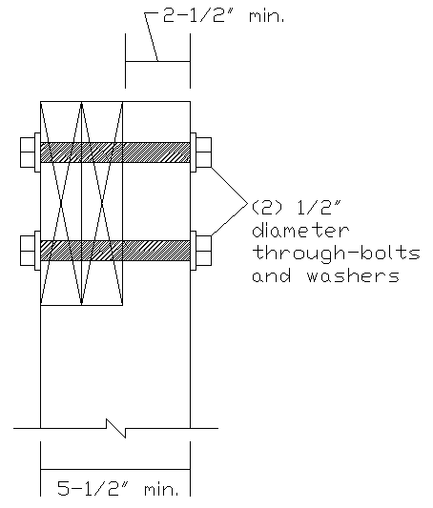
Figure 3

DECK POST-TO-FOOTING CONNECTIONS

Deck posts shall bear onto footings and be retrained to prevent lateral displacement at the bottom support. This may be achieved by using an approved manufactured connector or with a minimum 12-inch post embedment into concrete or soil surround pier. [R507.4.1]

BRACING

Exterior landings, decks, and stairs shall be positively anchored to the primary structure to resist both vertical and lateral forces or shall be designed to be self-supporting. Attachment shall not be accomplished by use of toenails or nails subject to withdrawal. [R507.8]

LEDGER ATTACHMENT

The deck ledger shall be minimum 2-inch by 8-inch nominal pressure-preservative-treated southern pine, incised pressure-preservative-treated Hem-fir, or approved, naturally durable, No. 2 grade or better lumber. [R507.9.1.1] For any other grade or species, or other connection details or loading conditions, the deck ledger connection shall be approved by a registered design professional. [R507.9.1.4]

Deck ledgers shall not support concentrated loads from beams or girders, nor shall be supported on stone or masonry veneer. [R507.9.1.1]

The band joist shall be minimum 2-inch-nominal, solid-sawn, spruce-pine-fir lumber or a minimum 1-inch by 9-1/2-inch dimensional, Douglas fir, laminated veneer lumber. Band joists shall be fully on the primary structure capable of supporting all required loads. [R507.9.1.2]

The connection between a deck ledger and band joist shall be constructed with ½-inch lag screws or bolts with washers in accordance with Table 5. Lag screws, bolts and washers shall be hot-dipped galvanized or stainless steel. The removal of siding and installation of flashing is required between the house and the ledger. NOTE: YOU MAY NOT ATTACH LEDGER BOARDS TO EXISTING CANTILEVERS, OPEN WEB TRUSSES OR STONE OR MASONRY VENEER. If these conditions occur, the deck must be freestanding.

TABLE 5
PLACEMENT OF LAG SCREWS AND BOLTS IN DECK LEDGERS AND BAND JOISTS
(Deck live load = 40 psf, deck dead load = 10 psf)
JOIST SPAN (feet) | ON-CENTER SPACING OF FASTENERS (inches)
JOIST SPAN (feet) | 1/2-inch diameter lag screw with 1/2-inch maximum sheathing ^{d} | 1/2-inch diameter bolt with 1/2-inch maximum sheathing | 1/2-inch diameter bolt with 1-inch maximum sheathing ^{f}
6 | 30 | 36 | 36
8 | 23 | 36 | 36
10 | 18 | 34 | 29
12 | 15 | 29 | 24
14 | 13 | 24 | 21
16 | 11 | 21 | 18
18 | 10 | 19 | 16
- Interpolation permitted. Extrapolation is not permitted.
- Ledgers shall be flashed in accordance with Section R703.4 to prevent water from contacting the house band joist.
- Dead Load = 10 psf. Snow load shall not be assumed to act concurrently with live load.
- The tip of the lag screw shall fully extend beyond the inside face of the band joist.
- Sheathing shall be wood structural panel or solid sawn lumber.
- Sheathing shall be permitted to be wood structural panel, gypsum board, fiberboard, lumber or foam sheathing.
The placement of lag screws and bolts in ledgers shall be in accordance with Table 6 and Figure 4 below. [R507.9.1.3]
TABLE 6
PLACEMENT OF LAG SCREWS AND BOLTS IN DECK LEDGERS AND BAND JOISTS
MINIMUM END AND EDGE DISTANCES AND SPACING BETWEEN ROWS
 | TOP EDGE | BOTTOM EDGE | ENDS | ROW SPACING
Ledgerª | 2 inches^{d} | ¾ inch | 2 inches^{b} | 1-5/8 inches^{b}
Band Joist^{c} | ¾ inch | 2 inches | 2 inches^{b} | 1-5/8 inches^{b}
a. Lag screws or bolts shall be staggered from the top to the bottom along the horizontal run of the deck ledger in accordance with Figure R507.2.1(1).
b. Maximum 5 inches.
c. For engineered rim joists, the manufacturer’s recommendations shall govern.
d. The minimum distance from bottom row of lag screws or bolts to the edge of the ledger shall be in accordance with Figure R507.2.1(1).

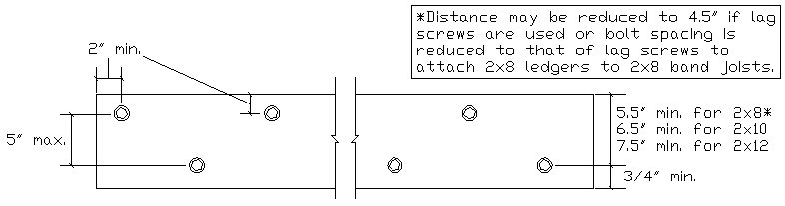
Figure 4

LATERAL LOAD CONNECTION

Where supported by attachment to an exterior wall, decks shall be positively anchored to the primary structure and designed for both vertical and lateral loads. [R507.8] Hold-down tension devices (such as the Simpson Strong-tie DTT2Z) shall be installed in not less than two locations per deck, within 24-inches of each end of the deck and each device shall have an allowable stress design capacity of not less than 1500 pounds (see example in Figure 5). If hold-down tension devices (such as the Simpson Strong-tie DTT1Z) are used, the minimum allowable stress design capacity of each device shall be 750 pounds and be installed in not less than four locations per deck (see example in Figure 6). [R507.9.2] Refer to manufacturer’s installation instructions for specific information. Note: Tension devices used with I-joists must be installed per I-joist’s manufacturer’s engineered installation instructions.

Where positive attachment cannot be verified during inspection, decks shall be self-supporting/free standing. [R507.8]

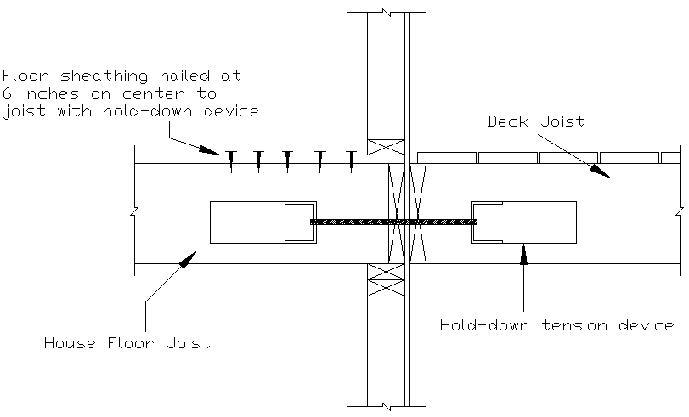
Figure 5

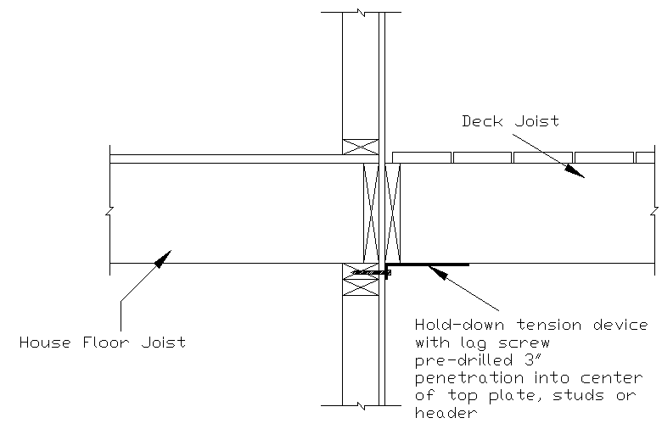
Figure 6

FRAMING AROUND A CANTILEVERED FLOOR SYSTEM

Attaching the ledger to a house overhang, chimney or bay window shall be prohibited. Use an alternate deck framing plan to achieve structural stability without fastening to the projection (see Figure 7 for example). [R507.9.1.2] Girders supporting deck joists shall not be supported by deck ledgers or band joists. [R507..9.1.1]

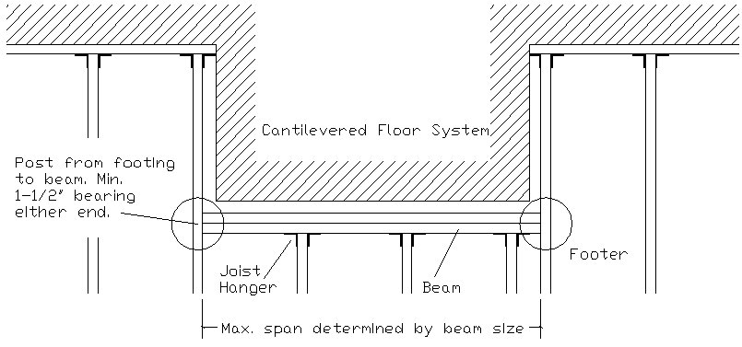
Figure 7

LATERAL RESTRAINTS AT SUPPORTS

Bearing locations and joist ends shall be provided with lateral restraints to prevent rotation. This can be accomplished by use of joist hangers or blocking between joists at a depth of at least 60 percent of joist depth. If accomplished by rim board, use (3) 10d nails or (3) No. 10x3-inch long wood screws to attach rim joist into each floor joist (see Figure 8). [R507.6.2]

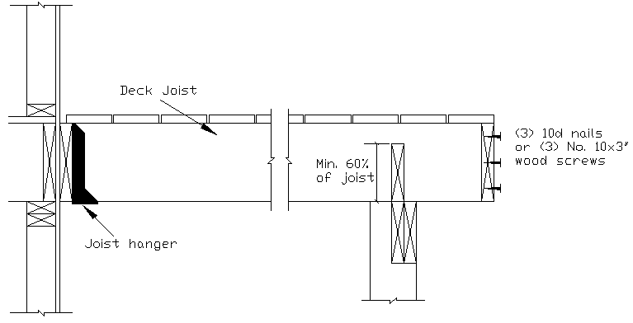
Figure 8

GUARD REQUIREMENTS

Porches, balconies, ramps or raised floor surfaces located more than 30” above the floor or grade, within 36” horizontally to the edge of the open side, shall have guards not less than 36” in height. [R312.1.1/R312.1.2] Open sides of stairs with a total rise of more than 30” shall have guards not less than 34” measured vertically from the tread nosing. [R312.1.2 exception 1]

Required guards on open sides of stairways, raised floor areas, balconies and porches shall have intermediate rails or ornamental closures which do not allow the passage of a sphere 4” or more in diameter. [R312.1.3] Exceptions:
- The triangular openings formed by the riser, tread and bottom rail at the open side of the stairway are permitted to be of such size that a 6” sphere cannot pass through.
- Openings for required guards on the sides of stair treads shall not allow the passage of a sphere 4-3/8” in diameter.
GUARD POST INSTALLATION

Guards supported by side of the deck framing:
When guard posts are attached to the inside or outside face of a deck joist or beam, that joist or beam must be secured to adjacent joists to prevent rotation. Connections that rely solely on fasteners withdrawn from end grain are not allowed. [R507.10.1.1]

Guards supported on top of deck framing:
Guards mounted on top of decking shall be attached to the deck framing or approved blocking and installed in accordance with the manufacturer’s instructions to ensure transfer of guard loads to adjacent joists. [R507.10.1.2]

Guard posts shall not be notched at the connection to the deck structure. [R507.10.2]

STAIR HANDRAIL REQUIREMENTS

Handrails shall be provided on at least one side of each continuous run of treads or flight with four or more risers. Handrails shall be located between 34” and 38” measured vertically from the sloped plane adjoining tread nosing. [R312.1.2 exception 2] It shall be continuous for the full length of the flight and return into newel posts.

Handrail shall comply with one of the following options:

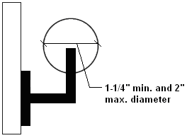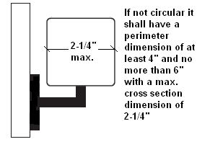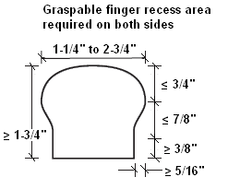
Figure 10

STAIR REQUIREMENTS

The maximum riser height shall be 8-1/4” measured vertically between leading edges of adjacent treads. There may be no more than a 3/8 inch variation in riser height within a flight of stairs. The minimum tread depth shall be 9” measured horizontally from beginning to end of tread and may have a uniform projection of not more than 1-1/2 inches when solid risers are used. The greatest tread depth within any flight of stairs may not exceed the smallest by more than 3/8 inch. [PA UCC]

Stairways may not be less than 3 feet in clear width and clear headroom of 6 feet 8 inches shall be maintained for the entire run of the stair. Handrails may project from each side of a stairway a distance of 3 1/2 inches into the required width of the stair. [PA UCC]

Landings: There shall be a floor or landing at the top and bottom of each stairway. The width perpendicular to the direction of travel shall be not less than the width of the flight served. The depth in the direction of travel shall be not less than 36 inches. [R311.7.6]

Open risers, located more than 30 inches to the floor or grade below shall not permit the passage of a 4-inch-diameter sphere. [R311.7.5.1]

GLAZING IN HAZARDOUS LOCATIONS

Glazing (or glass) in the following hazardous locations shall be tempered: [R308.4]
- In guards and railings, including nonstructural in-fill panels and structural baluster panels. [R308.4.4]
- Adjacent to stairs, landings and ramps. Glazing where the exposed bottom edge is less than 36-inches above the plane of the adjacent walking surface of stairs, landings or ramps. [R308.4.6]
  - Exception: A minimum 1-1/2” cross-sectional rail is installed between 34-38 inches above the walking surface. Such rail shall be capable of withstanding 50 plf without contacting the glass. Any glazing a minimum of 36-inches horizontally from the stairway, ramp or landing does not have to be tempered.
- Glazing less than 36-inches above the bottom landing and within 60-inch horizontal arc less than 180 degrees from the bottom tread nosing. [R308.4.7]
  - Exception: Where glazing is protected by a guard, complying with Section R312, and the plane of the glass is more than 18-inches from the guard.

DECKING REQUIREMENTS

Decking material shall be 2”x6” or 5/4” lumber or other approved composite matter. Any synthetic or composite material shall be approved by the building official, only after an ICC Evaluation Report of the particular product. The reports may be found at http://www.icc-es.org/Evaluation_Reports/index.shtml by searching the manufacturer or product name. Decking shall not have a span that would compromise a 50 lb. per square foot load capacity. Maximum allowable joist spacing for wood decking (excluding stairways) shall be in accordance with Table 7. [R507.7]
TABLE 7
MAXIMUM JOIST SPACING FOR WOOD DECKING
DECKING MATERIAL TYPE AND NOMINAL SIZE | DECKING PERPENDICULAR TO JOIST |  | DECKING DIAGONAL TO JOIST
 | Single span | Multiple span | Single span | Multiple span
 | Maximum on-center joist spacing (inches)
1-1/4-inch thick wood | 12 | 16 | 8 | 12
2-inch thick wood | 24 | 24 | 18 | 24

DECK APPLICATION CHECKLIST

Municipality: Date:

Site Address:

Applicant Name: Phone: ______
Contractor Name: Phone: ______

Provide the following information:

- Proposed Deck Size: ___________________________
(width x depth)

- Height Above Grade: __________________________
(at highest point)

- Footing Tributary Area(s): ______________________

- Footing Size(s): _______________________________
(example: 16” round or 12”x12”)

- Footing Spacing: ______________________________
(measured from centerlines of footings)

- Decking Material: _____________________________
(example: 1-1/4” wood, composite)

- Decking Direction: ____________________________
(perpendicular to joists or maximum 45-degrees)

- Ledger Board Size: ____________________________

- Joist Span: ___________________________________
(measured to centerline of beam(s))

- Joist Size: ____________________________________
(example: 2x10)

- Joist Spacing: ________________________________
(example: 12” or 16” on center)

- Joist Cantilever Length: _____________________
(measured from centerline of beam to end of joist)
- Beam Span: _______________________________
(measured from centerline of posts)

- Beam Size / Number of Plies: _______________
(example: (2)2x10, engineered lumber)

- Beam Cantilever Length (if any): _____________
(measured from centerline of post to end of beam)

- Post Size: _________________________________

- Post Spacing: _____________________________
(measured from centerline of posts)

- Existing House Band Board: ________________
(2-inch-nominal, solid-sawn, spruce-pine-fir lumber or a minimum 1-inch by 9-1/2-inch dimensional, Douglas fir, laminated veneer lumber)

- Cladding of House: ________________________
(vinyl siding, brick, masonry)

- Deck Guard Height: _______________________

- Stair Riser Height: _________________________

- Stair Tread Depth: _________________________

- Stairway Width: ___________________________
(clear width minimum 36-inches and clear headroom of 6 feet 8 inches)

